PARISH OF
PORTRUSH & BUSHMILLS
Part of the North Connor Pastoral Community
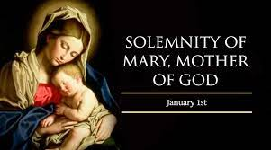

Sunday 1st January 2022
Mary Mother of God
Sunday A/Weekdays 1 Psalter week 2
Fr Kevin McGuckien (Parish Priest)
028 7083 2534
Email: pp@portstewartparish.co.uk

Fr Patrick Delargy
Parochial house/Parish Office 7082 3388
E: portrush@downandconnor.org
St Patricks Church Portrush
www.portrushparish.website

Parish Office this week:
Tuesday & Thursday 09.30am-1.00pm

MASSES THIS WEEK
Monday, Tuesday & Friday – 10.30am
Sunday - 12.00pm

MASS IN PORTSTEWART
Tuesday: Mass at 7.00pm
Wednesday – Friday: Mass at 9.30am
Saturday – 5pm
Sunday – 10.00am

MASS IN ST MALACHY’S, COLERAINE
Mon, Tues & Friday 10am
Thursday – 7pm
Saturday vigil at 6pm & Sunday at 11am

Any item for inclusion in the Bulletin must be received by Wednesday 5pm
SVP Helpline 07508 549 574
SVP Clothes Bank situated in the church car park

All Masses are streamed & recorded online
At www.churchmedia.tv . Masses are available to view for up to two weeks. For any difficulties with accessing Mass please contact Melissa on 02887738494

The church is open for private prayer
Monday – Saturday 9am – 5.30pm
and Sunday after 12 noon Mass until 5.30pm.

ST PATRICK’S ALTAR SOCIETY
7th – 20th January – Mary Gordon & Evelyn Duggan
21st January – 3rd February – Ann Maguire & Pat Neely
MINISTERS OF THE WORD
Sunday 8th January – Caroline McWilliams -Owen
MINISTERS OF THE EUCHARIST
Sunday 8th January – Stephen O’Neill

ANNIVERSARIES: Robert Bannister
Mary Dickson, Bridget McMullan, Andrea McKeown, Seamus Martin, Agnes Donaghy, Annie Kirkpatrick, John-Eddie & Eileen Mullan

COLLECTIONS
Thank you for your continuing generosity!

LORETO OPEN NIGHT
Loreto College Coleraine invites parents and transferring pupils to attend its Open Day on
Saturday 7 January 2023
Those who live West of the River Bann are asked to attend at 9.30am for the principal’s address
and those who live East of the River Bann should arrive at 11.00am for the second Principal’s address.
Both talks will be followed by organised tours of the school

All P6 & P7 Pupils and Parents are welcome
Please visit our website: www.loretocollege.org.uk for more details
We very much look forward to meeting you

SPECIAL BELFAST PILGRIMAGE TO FATIMA
9-14th June 2023 Ex Dublin for Feast Day of Saint Anthony Patron Saint of Portugal visit Saint Anthony’s birthplace and baptismal font in Lisbon contact James Treacy 0035361921470

FIRST FRIDAY EUCHARISTIC ADORATION
Eucharistic Adoration will take place after Friday Morning Mass on the 6^{th of} January.
If anyone would like to volunteer for a time, please pass your name to Julie Short

1st JANUARY (New Year's Day)
Today is the first day of a new year!
Spend some time together thinking about what your hopes are for this new year for yourself, for your family, for your local community and for the world.
Write each of these hopes on a piece of paper and put them all inside a jar. You could take these hopes out at different points in the year, to remind yourself of them. Or come back together regularly to add new hopes to the jar.
What could you do to make some of these hopes a reality?

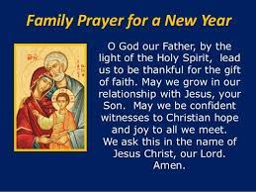

NEW ALPHA COURSE
This New Year, all are welcome to join us as we start a new Alpha course, designed to explore the basics of the Christian faith & its meaning in our lives today.
Alpha will be run in the Anchorage Complex, Portstewart: 7-9 pm Mondays 16th January to 3rd April. Feel free to come along to the first taster evening (16th January) to see what you think. Each evening will begin with a light meal followed by a short film on life, faith & meaning, and end with an opportunity for discussion. There is no charge.
Contact a team member to sign up or if you have any questions: Ernestine 077 6064 7665; Bernadette 079 4173 3502 o
"The joy of the gospel fills the hearts and lives of all who encounter Jesus. Those who accept his offer of salvation are set free from sin, sorrow, inner emptiness and loneliness. With Christ, joy is constantly born anew.” (Pope Francis: Evangelii Gaudium).

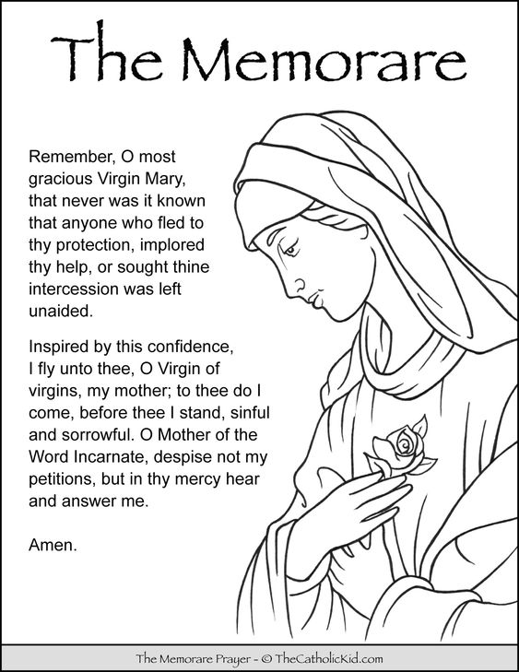

POPES PRAYER INTENTION JANUARY
For educators
We pray that educators may be credible witnesses, teaching fraternity rather than competition and helping the youngest and most vulnerable above all.

